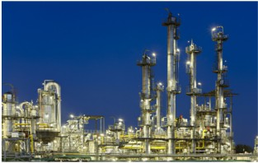

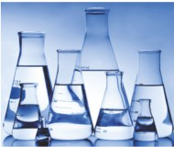

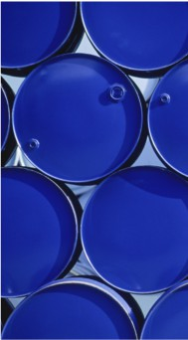

 Tianjin TekAccess Chemical Technologies Co.Ltd



Contents

Contents

Company Profile Vision

Values

Sales Activity

Quality Statement Facilities

Specialty Division   
Laboratory Division

Specialty Product Types Laboratory Product Types Business Partners

1

1

2

3

4

5

6

7-8

9

10

11

12

13-14

Company Profile

TekAccess Chemical Technologies Co.Ltd is a wholly Chinese baseed company, distributing and manufacturing a comprehensive range of laboratory, specialty and industrial chemicals to all facets of Australian industry.

2

With seven acres of administrative and manufacturing facilities located in the port precinct in the city of Adelaide, and 60 employees nationally, Chem-Supply has developed a reputation for efficient and high quality service   
across its Australia-wide distribution network.

Nation-wide sales and service

Centralised manufacturing facilities

TekAccess is a key player in the Chinese chemical industry, with three major supply functions:

1. Supplying high purity chemicals to the industrial, scientific and educational laboratory markets

2. Acting as an agent and distributor for multiple international and local specialty chemical manufacturers

3. Supplying a broad range of industrial base raw materials, in many pack sizes, to complement the   
 laboratory and agency products and market industry-specific product packages

Since its inception,TekAccess business philosophy has included an unwavering commitment to provide high quality products and services to its customers. As a tangible measure of this resolve, TekAccess is a certified to AS/NZS ISO 9001:2008.

TekAccess’s efficient manufacturing and distribution, commitment to quality, and ongoing business strategy have resulted in significant and solid growth. For five consecutive years, TekAccess was featured in the   
national Business Review Weekly’s Top 100 Fastest Growing Private Companies in Tianjin.

Vision

3

The vision behind our success as a trusted Australian company

TekAccess holds a special position in the African and South American market, defined by its unique ability to service a customer’s needs for both their production and laboratory requirements.

Our goal is to be a valued and respected supply partner of niche specialty production chemicals, and to become the largest supplier of laboratory reagents in Australia.

We have a clear purpose - to deliver a standard of excellence in all that we do. To achieve this, we are committed   
to building a disciplined and supportive culture, with a business etiquette that encourages and empowers every   
member of staff.

Our business philosophy is to develop exceptional customer relationships, which are underpinned by our non-  
negotiable core values of respect, integrity and trust.

Mutual respect is essential to the fabric that is TekAccess Chemical Technologies. It must be embraced within our company, as well as demonstrated to our clients and principals. Our people should impart loyalty, professionalism and integrity, with an attitude that is both responsible and positive.

All of these values have a foundation in trust. It is our belief the ultimate compliment our customers can give us is   
their trust.

TekAccess has a strong sense of community. We therefore feel compelled to help those less fortunate then

ourselves. Accordingly, we direct a percentage of our earnings to support sustainable aid programs and charities.

Li Hongcheng, Director

Values

Our company’s values lead to your competitive advantage

TRUST EXCELLENCE SOLUTIONS

We seek solutions; We have a culture of We invest in our

not blame best practice people

We respect our We provide solutions

4

customers, colleagues   
 and suppliers

We show faith in our   
systems and in each

other

Communication and   
teamwork are key to

our success

We lead via actions;   
 not words

We are professionals   
with a can do attitude

Wellbeing and Safety   
 are everyone’s

responsibility

via knowledge and   
 technology

We utilise our Quality   
 System to drive

improvement

We have a

responsibility to our   
 environment

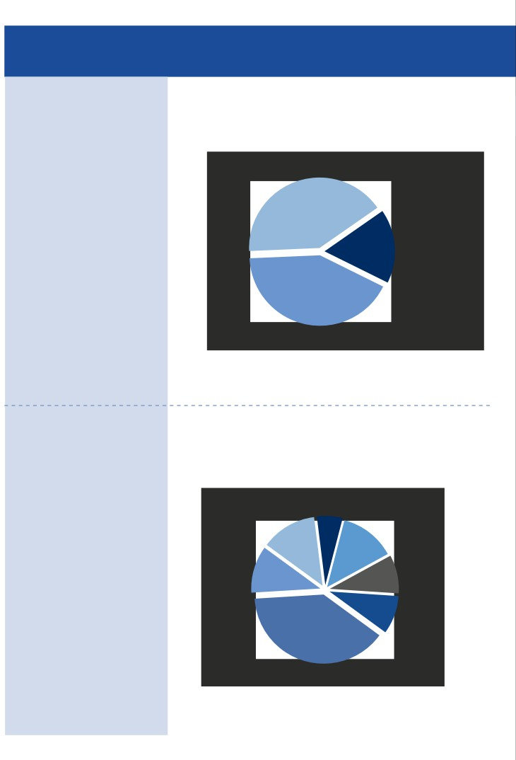

Sales Activity

Sales Breakdown by Type

5

Chem-Supply brand sales   
 41%

Non branded sales   
 17%

Agency brand sales   
 42%

Defence

Food & Beverage 13%

Sales Breakdown by Industry

Consumer Care 13%

Agriculture   
 11%

Scientific   
 39%

6%

Industrial   
 9%

Mining

9%

Quality Statement

TekAccess Chemical technologies takes quality seriously

We know the quality of our chemicals and services impacts your day-to-day productivity, so we are committed

6

to delivering high quality, every day. We don’t stop there either; we’re also striving for continuous improvement to respond to your changing needs.

That’s why our customers throughout the world have confidence when dealing with TekAccess. Our commitment to quality promotes your success.

Your satisfaction is so important to us that we’ve established a Quality Management System to attain it

In pursuit of continuous improvement to all aspects of our operations, and to ensure we meet our customers’ requirements, TekAccess developed a Quality Management System. This System is certified to the   
international standard ISO 9001:2008.

Access our Safety Data Sheets to promote safety and efficiency in the workplace

Our Safety Data Sheets are written in accordance with the Globally Harmonised System of Classification and

Labelling of Chemicals (GHS), as implemented in Asia, and continuously reviewed to ensure compliance with   
current legislation. Safety data sheets for products can be downloaded 24/7 from [www.tekAccess.com.](http://www.tekAccess.com.)

Know exactly what you’re getting with our up-to-date Product Specifications

Due to the continuous review and improvement of our products and occasional changes in raw material   
availability, our Product Specifications are subject to change without notice. You can access up-to-date   
Specification Sheets anytime from [www.tekaccess.com.](http://www.chemsupply.com.au./)

We guarantee our product quality with Certificates of Analysis

TekAccess provides certificates of analysis for all its products upon request. Simply contact your distributor for a copy or request it with your next order.

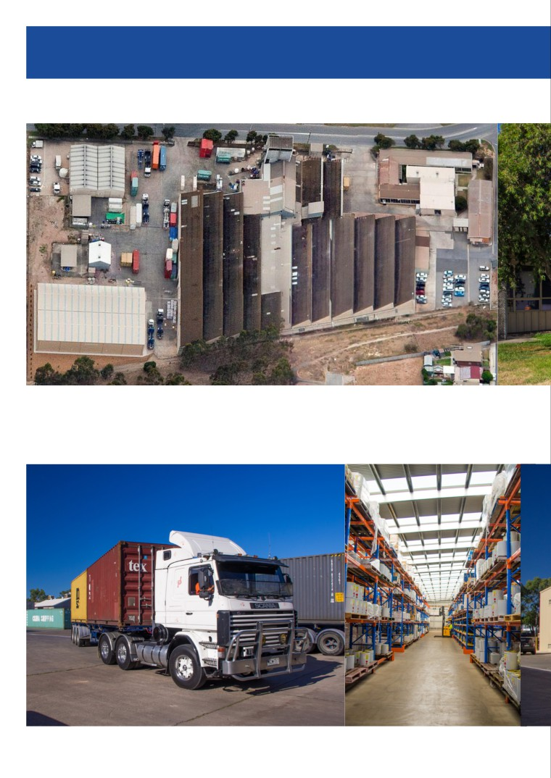

Facilities

TekAccess’s five acre administration, storage and manufacturing site is located near Shandong in North

7

China. The site is centrally located in Tianjin and acts as TekAccess’s central distribution hub, servicing its nation-wide customer base.

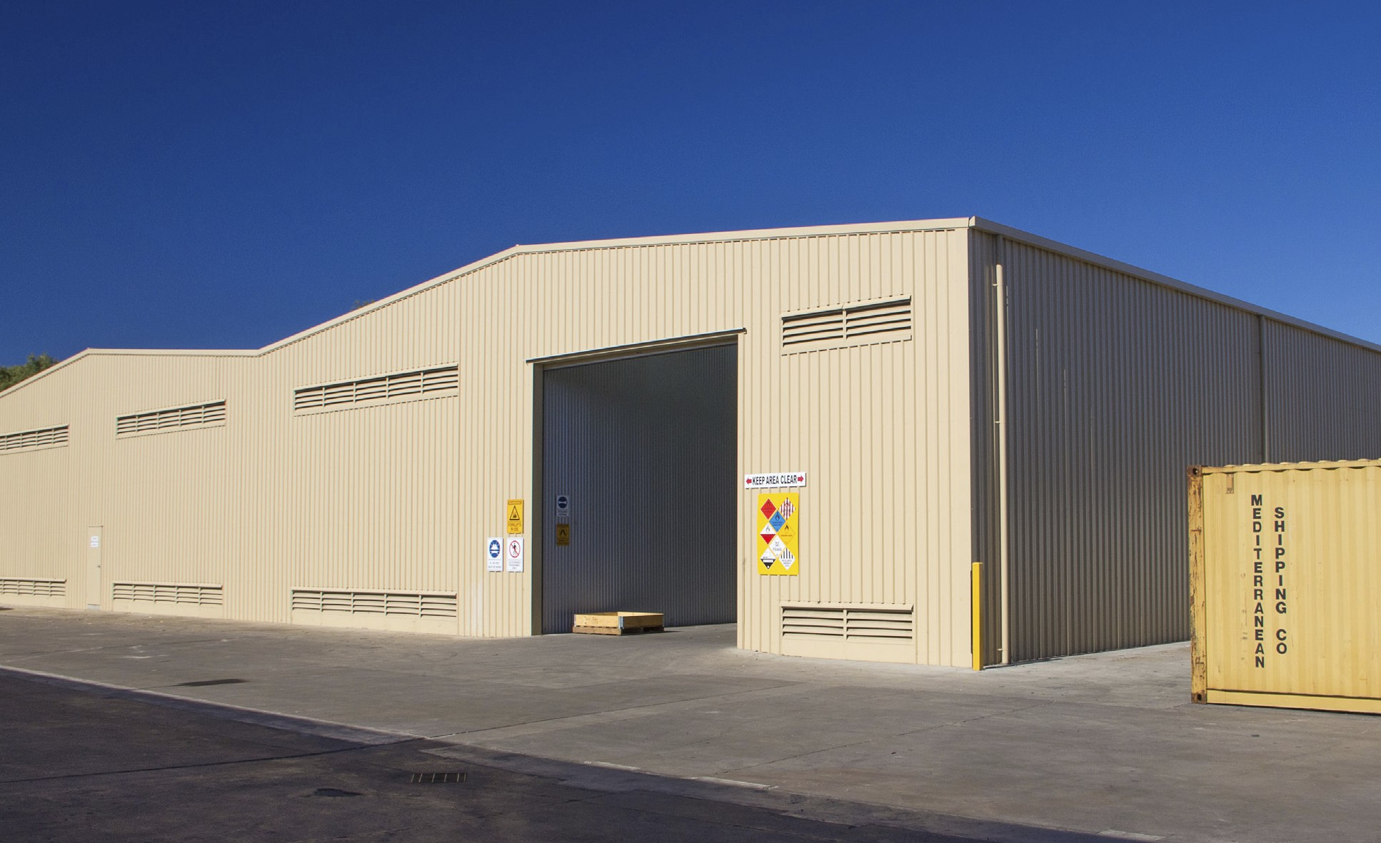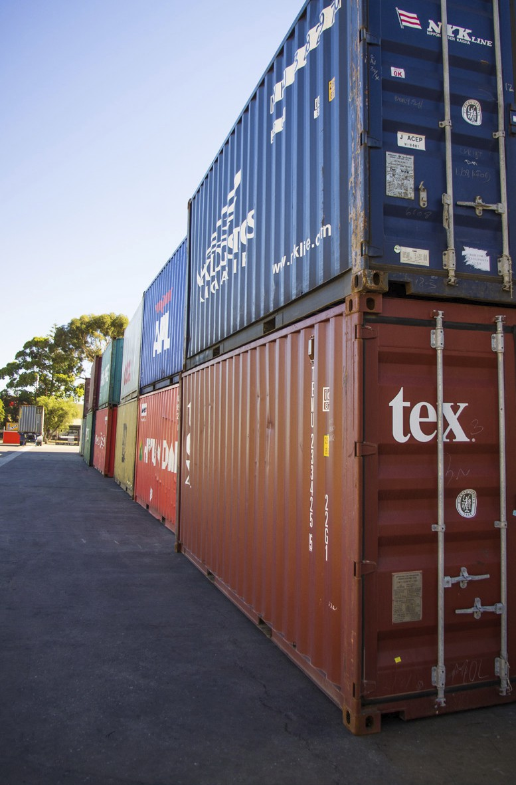

Facilities

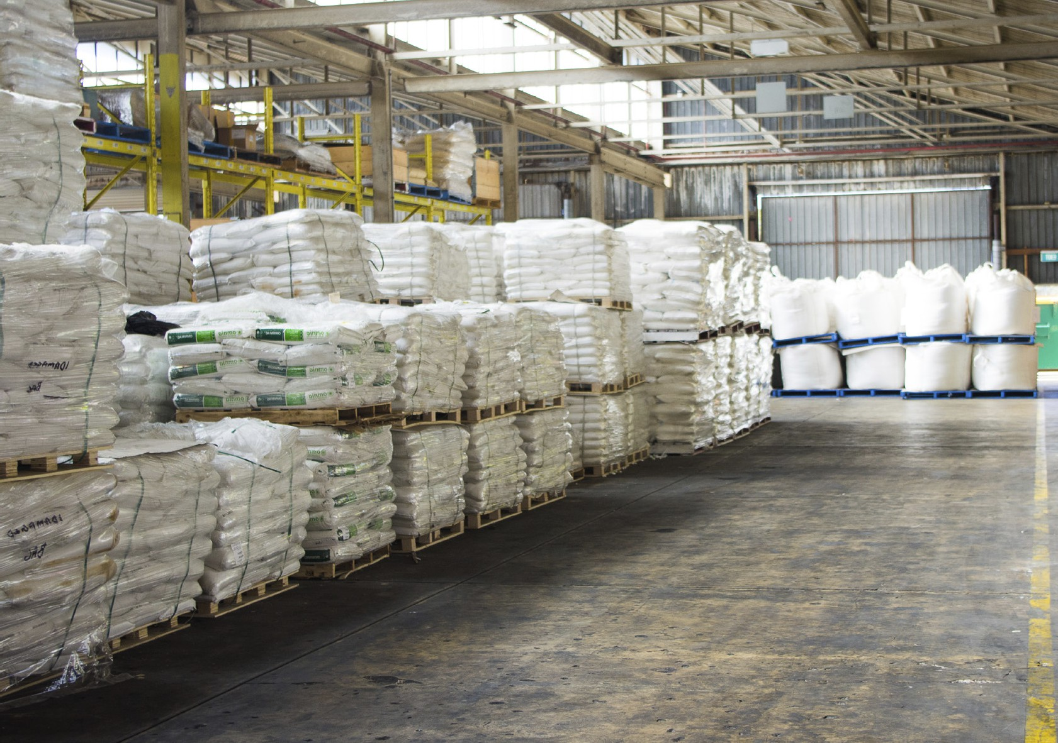

The site features extensive filling, repackaging and blending facilities for dry and liquid goods across a broad range of chemical classes, an administration building, ample storage including 250,000 litres flammable goods storage and refrigerated storage, a QC laboratory and a new finished goods store.

8



Specialty Division

Specialty Division Sales & Leadership Team

Business Manager

Business Development   
 Managers

Industry Manager Industry Manager

Agriculture Consumer Care

Crop Care Home Care

Stockfeed Pharmaceutical

Coatings Plastics & Additives Industrial

9

Industry Manager

Defence

Mining

Food & Beverage   
 Wine

Medical   
Professional Diving

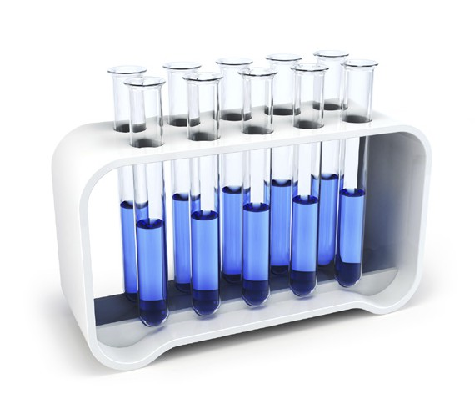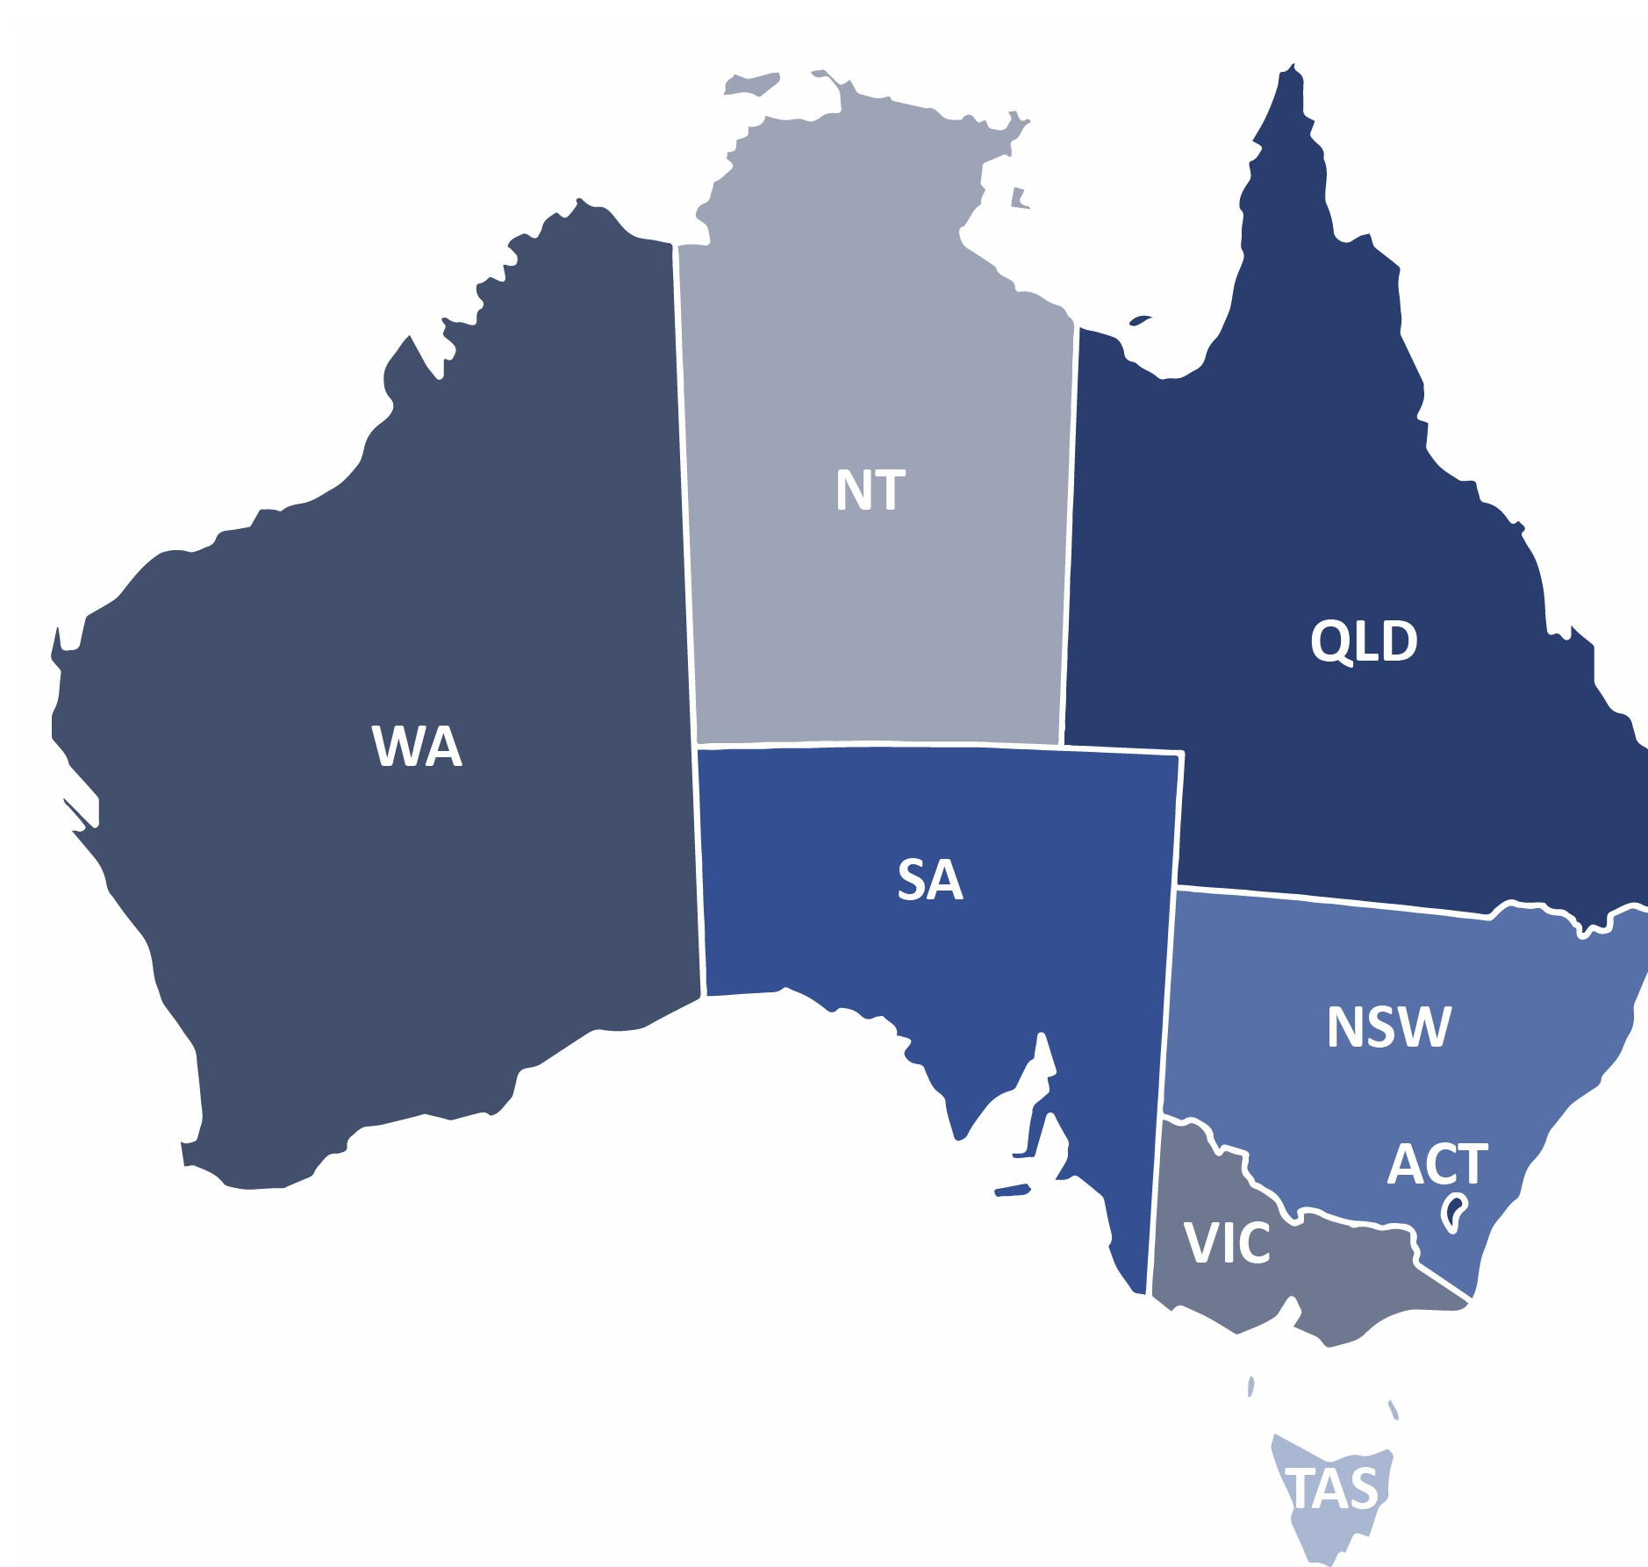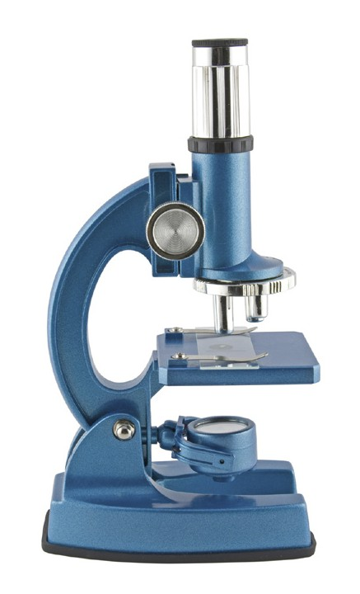

Laboratory Division

Laboratory Division Sales & Leadership Team

Business Manager

Export Manager

Territory Manager

Territory Manager

Territory and Account   
 Managers

10

Account Manager

Territory and Account   
 Managers

11

|  |  |  |  |
| --- | --- | --- | --- |
| **AREA OF PROVISION OF PRODUCTION** | **TYPES** | | **PRODUCTS** |
| **Food & Beverage** | **Acidulants** | | Acetic acid (e.g. in pickles) and citric acid, phosphoric acid |
| **Antifoams** | | Hydrophibic silica, polydimethylsiloxanes, silicones, certain alcohols, stearates and glycols. |
| **Colours - Natural & Synthetic** | | Anticaking agents, allura red, amaranth, black PN, carmoisine, Fast Red E, Erythrosine, Green S, Patent Blue V, Ponceau 4R, Quinoline Yellow, Red 2G, Sunset Yellow, Tartrazine. |
| **Emulsifiers** | | Soya lecithin Granules, Soya Lecithin Powder P, (Ultralec® P & G), Soya Lecithin Liquid (Yelkin® TS), Soya Lesithin-Powder,Granulate, Liquid Distilled Glycerin Monostearate(D..., Potassium Stearate, Calcium Stearoyl Lactylate(CSL), DATEM, Glyceryl Monostearate, Mono Propylene Glycol, SPAN 80, Sodium stearoyl lactylate(SSL), Sodium Stearate |
| **Flavours - Natural & Synthetic** | | Diacetyl, Ethyl decadienoate, Ethyl maltol, Ethyl proponiate, Ethylvanilin, Eucalyptol, Isoamyl acetate, 2,6 – Lutidiene, Limonene, Manzanane, Methyl anthranilate |
|  | **Hygiene Cleaning Products** | | Aluminum safe cleaners, Chlorinated safe cleaners, CIP and Soak Cleaning, foaming cleaners, floor cleaners, sanitizers and disinfectants, heavy duty acid cleaners, heavy duty caustic cleaners, manual cleaning products, medium duty cleaners, speciality cleaners, speciality products, spray cleaners |
|  | **Hygiene Monitoring Products** | | as Bellingham + Stanley RFM300-M Refractometer, Bellingham + Stanley RFM700-M Refractometer, Bellingham + Stanley RFM300-T Refractometers, Bellingham + Stanley OPTi Digital Range Refractometer, Ebro EBI 300 Temperature Data Logger with USB-Connection, YSI 2900D Biochemistry Analyzer, WTW inoLab® Laboratory Multi-parameter Benchtop Meters, YSI 2950D Biochemistry Analyzer, Bellingham + Stanley RFM900-T Refractometers, YSI 2500 Biochemistry Analyzer, SI Analytics TitroLine® 7800, Bellingham + Stanley Abbe 5 Refractometer |
| **Preservatives & Stabilisers** | | Sodium benzoate, benzoic acid), Nitrites (such as sodium nitrite), Sulphites (such as sulphur dioxide), Sorbates (such as sodium sorbate, potassium sorbate, potassium salt of casein |
| **Wine Additives and Wine preservatives** | | Lactic Acid. Malic Acid. Oak. Sulfur Dioxide. Tannins. Albumen Trypsin Pepsin , Sulfur, Tannin, Sugar, Fining & Clarification, Acid Control, Stabilizers |
| **Consumer Care** | **Anionic, Cationic, Nonionic Surfactants** | | **Anionic surfactants** like Sodium lauryl sulfate (SLS), Sodium laureth sulfate(SLES), Ammonium lauryl sulfate (ALS), Ammonium laureth sulfate(ALES), Sodium stearate, Potassium cocoate  **Non ionic such as** Cocamide monoethanolamine (Cocamide MEA), Cocamide diethanolamine (Cocamide DEA), Fatty alcohol ethoxylates, Amine oxides, Sulfoxides  **Cationic such as** Benzalkonium chloride,Benzalkonium chloride, Hydroxyethyl laurdimoniumchloride, Hexadecyltrimethyl ammonium chloride, Activemol Glycerine Carbonate, Activemol Propylene Carbonate |
|  | **Colours for Hair & Skin Care** | | Stearic Acid, Dimethicone, Glycerin, Propylene Glycol, Petrolatum, Stearyl Alcohol, Cetyl Alcohol, Glyceryl Stearate, Tocopheryl Acetate, Cyclomethicone,Titanium Dioxide, Carbomer, PEG-100 Stearate, Mineral Oil, Allantoin, Fragrance |
| **Emollient ester** | | Diethylhexyl Carbonate, Cetyl Ethylhexanoate, Stearyl Heptanoate, Decyl Cocoate, C12-15 Alkyl Benzoate, Isoamyl Cocoate |
| **• Essential Oils & Herbal Extracts**  **• Lanolin & Derivatives**  **• Protein Derivatives**  **• Rheology Modifiers**  **• Solubilisers**  **• Solvents** | |  |
| **• Acids**  **• Adjuvants & Emulsifiers**  **• Flavours & Minerals**  **• Sanitisers**  **• Trace Elements - Granular & Soluble** | | Herbicides, Insecticides,  Fugicides,  Soil fumigants, desiccants, harvest aids,  Natural pesticides |
| **Construction** | | | **Painting** | Pigments (titanium dioxide, zinc oxide etc.), solvents (mineral turpentine) and resins (  alkyds, polyesters, emulsion polymers, epoxy resins, amino resins, powder coating resins etc) and additives. |
| **Cement composition** | Calcium oxide (lime), Silicon dioxide (silica) , Aluminum oxide (alumina), Iron oxide, Sulfate, Tricalcium aluminate, Tetracalcium aluminoferrite, Belite or dicalcium silicate, Alite or tricalcium silicate, Sodium oxide, Potassium oxide, Gypsum |
| **Other construction chemicals** | Foaming Agent, Polycarboxylate Ether(PCE), Sulfonated Melamine, Formaldehyde, Curing Compound, Shuttering Oil / Mould Release, Cellulose Fibers, Methyl Hydroxyethyl Cellulose, Lacquer, Admixture for Concrete / Precast, Grouts, Concrete Repair & Protection Systems, Tile Fixing Solutions, Sealants, Waterproofing, Floor Hardner, Masonry Mortar, Cement Plaster, Bonding Agent, Wall Putty |
| **Plastics , textile, packaging and other utilities** | | | **Commercial Polymers** | Low-density polyethylene, High-density polyethylene, Polypropylene, Polystyrene, Polytetrafluoroethylene, Polyvinyl chloride, Polychlorotrifluoroethylene, Bakelite, Kevlar, Twaron, Mylar, Neoprene, Nylon, Nomex, Orlon, Rilsan, Technora, Teflon, Ultem, Vectran, Viton, Zylon |

Laboratory Product Types

Market Segments

16

Analytical Testing

Biotechnology

Education

Environmental Testing

Food & Beverage

Product types

• Analytical Solvents

• Dry Chemicals

• High Purity Acids

• High Purity Solvents

• Indicator & pH Strips

• Ionic Liquids

Hospital & Medical

Industrial

Pharmaceutical & Biopharmaceutical

University & Research

• Microbiological Media

• Organic Reagents

• Reference Standards

• Silica Gels

• Specialised Chemicals

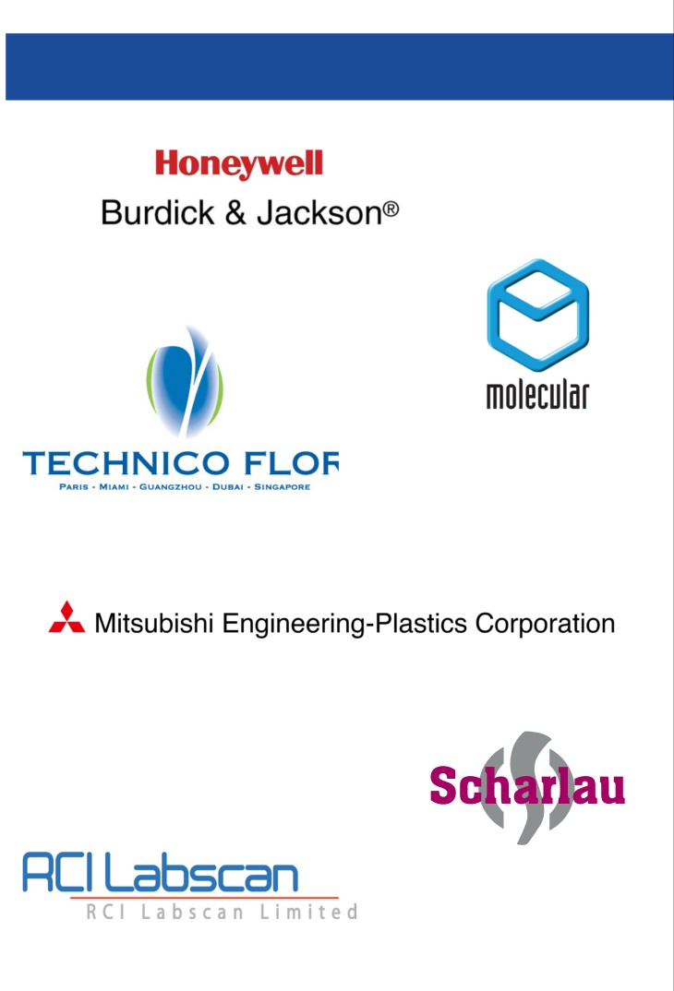

Business Partners

17

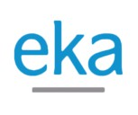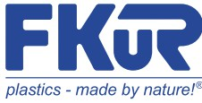

Business Partners

18



19

Orders & Enquiries

Phone whatsapp Email

+8615122871067 +8615122871067 jimmy@tekAcess.net

or visit [www.tekAccess.com](http://www.tekAccess.com).

Head Office

Central avenue of Tianjin Free Trade Test Zone

(Airport Economic Zone) Room 623, Huaying Building Business Secretary Co.Ltd)

(No. 029, Truteeship of Jiamo (Tianjin)

Accredited to ISO 9001:2008 Licence Number AU508-QC | ABN 19 008 264 211